

CSA1109-Object Oriented Analysis and Design

CO-3 AT -1

Experiments

Ashmi P S
192571004
Activity Diagram – Online Course Reservation System

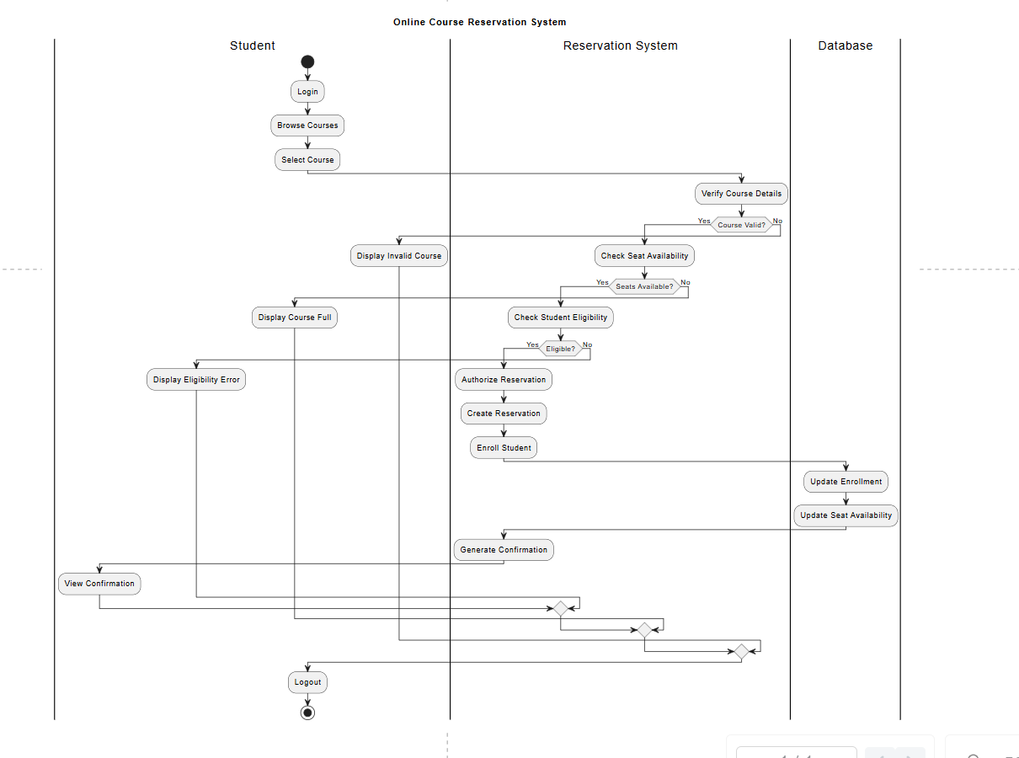
1. Main Actors / Swimlanes
Use 4 swimlanes:
- Student
- Online Course Reservation System
- Central University Management System (CUMS)
- Database

2. Activity-by-Activity Explanation
A. Student Activities
Start → Login/Register
The student first enters the system. If the student is new, registration is performed. Existing students log in using their credentials.
Browse Courses
After successful login, the student can browse the list of available courses.
Search / Filter
The student can search courses based on:
- Course name
- Department
- Credits
- Academic requirements
- Prerequisites
- Faculty
- Schedule
- Student preferences
View Course Details
The student views complete information about the selected course before making a reservation.
Select Course
The student selects the course that satisfies their academic requirements and preferences.

3. System Verification
After course selection, the Online Course Reservation System sends the selected course information to the Central University Management System (CUMS).
CUMS verifies:
- Course ID
- Course existence
- Course status
- Course prerequisites
- Course credits
- Academic eligibility
- Current course capacity
Decision 1: Course Valid?
No → Display invalid/unavailable course message → Student can browse again.
Yes → Continue to seat availability checking.
5. Seat Availability Decision
The system checks the current number of available seats.
Decision 2: Seats Available?
No:
Seats Available = 0
↓
Display "Course Full"
↓
Return to Course Browsing
Yes:
Seats Available > 0
↓
Check Student Eligibility
This decision is important because the question specifically says seat availability verification.

6. Student Eligibility Verification
The system verifies whether the student satisfies the course requirements.
For example:
- Required prerequisites completed?
- Correct academic year?
- Required department?
- Credit requirements satisfied?
Decision 3: Student Eligible?
No → Display eligibility error → Student can select another course.
Yes → Continue with reservation.

7. Reservation and Enrollment
Once the student is eligible and seats are available:
Authorize Reservation
↓
Create Reservation
↓
Enroll Student
↓
Update Course Capacity
↓
Store Enrollment Information
↓
Generate Confirmation
↓
Send Confirmation to Student
This is the successful main flow.

8. Database Activities
The database should be represented as a separate swim lane because the question says the system must maintain:
Student Information
- Student ID
- Name
- Department
- Academic year
- Contact details
Course Information
- Course ID
- Course name
- Credits
- Prerequisites
- Faculty
- Capacity
Reservation Information
- Reservation ID
- Student ID
- Course ID
- Reservation date
- Reservation status
Enrollment Information
- Enrollment ID
- Student ID
- Course ID
- Enrollment date
- Enrollment status
Seat Availability
The database is updated after successful enrollment:
Old Available Seats
↓
Successful Enrollment
↓
Available Seats = Available Seats - 1

9. Important Decision Nodes for Diagram
For a high-quality OOAD activity diagram, include these diamonds:
Decision | Yes | No
Valid Login? | Browse courses | Show error / Retry
Course Selected? | Verify course | Continue browsing
Course Valid? | Check seats | Show invalid course
Seats Available? | Check eligibility | Course full
Student Eligible? | Authorize reservation | Show eligibility error
Reservation Authorized? | Enroll | Reject reservation
More Courses? | Browse again | Logout

